M/AH/HH系列渣浆泵 ZJ/ZJB系列渣浆泵

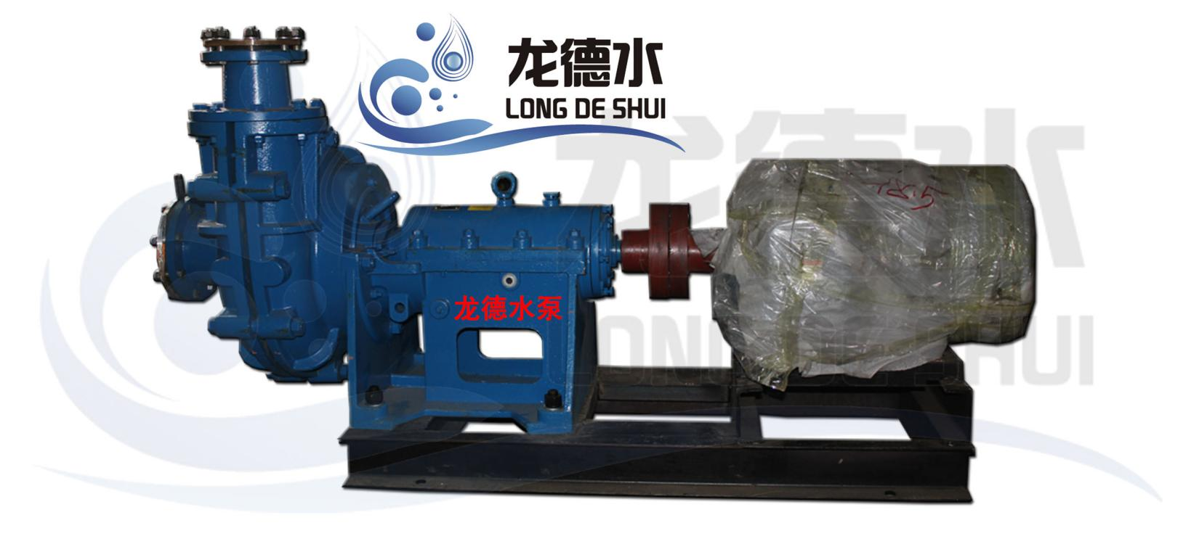

特点：
采用现代CAD设计方法，水力性能优良，效率高和磨损率低；流道宽畅，抗堵塞性能好，汽蚀性能优越；在允许的压力范围内可以多级串联使用，其允许最大工作压力为3.6Mpa。

性能参数
型号 | 转速  N  R/min | 流量  Q  M³/h | 扬程  H  m | 效率  N  % | 轴效率  Pa  kw | 必需汽蚀余量  （NPSH）r  m | 配电电机 |  | 口径 | 配电电机 |  |  |  |  | 传动型式 |  |  | 泵重  Kg
 |  |  |  |  |  |  | 型号 | 功率/电压  Kw/v | 出口/入口  mm/mm | DC | CV | ZV | CR | HC | 长  mm | 宽  mm | 高  mm | 泵重  Kg
2/1.5B-AH | 1200 | 7.2  14.4  21.6 | 8.5  8  7 | 18  25  35 | 0.93  1.25  1.18 |  | Y90L-4  Y1000L1-4 | 1.5/380  2.2/380 | 38/51 |  | √ |  |  |  | 592 | 371 | 381 | 104
2/1.5B-AH | 3200 | 21.6  37.8 | 64  57 | 61  57 | 11.96  13.97 | 3  4 | Y160M₂-2 | 15/380 | 38/51 |  |  |  | √ |  | 592 | 371 | 381 | 104
3/2C-AH | 1300 | 21.6  32.4  42.48 | 14.5  14  13 | 45  52  56 | 1.9  2.38  2.69 |  | Y112M-4  Y132S-4 | 4/380  5.5/380 | 51/76 |  |  |  | √ |  | 768 | 441 | 464 | 191
3/2C-AH | 2700 | 50.04  64.8  88.56 | 62.3  60  56 | 45  52  56 | 18.7  20.4  24.1 | 4  5.5  8 | Y200L₁-2  Y180M-2 | 30/380  22/380 | 51/76 |  |  | √ |  |  | 768 | 441 | 464 | 191
4/3C-AH | 1000 | 28.8  68.4  108 | 11  10.1  7.6 | 50  69  65 | 1.73  2.73  3.44 | 2.2 | Y132S-4  Y132M-4 | 5.5/380  7.5/380 | 76/102 |  |  |  | √ |  | 843 | 527 | 524 | 263
4/3C-AH | 2000 | 61.2  108  158.4 | 44  42  37.1 | 50  65  71 | 14.67  19  22.54 | 3.6  4.5  6 | Y20L₁-2 | 30/380 | 76/102 |  |  |  | √ |  | 843 | 527 | 524 | 263
4/3D-AH | 1000 | 28.8  68.4  108 | 11  10.1  7.6 | 50  69  65 | 1.73  2.73  3.44 | 2.2 | Y132S-4  Y132M-4 | 5.5/380  7.5/380 | 76/102 |  |  |  | √ |  | 943 | 538 | 592 | 263
4/3D-AH | 2000 | 61.2  108  158.4 | 44  42  37.1 | 50  65  71 | 14.67  19  22.54 | 3.6  4.5  6 | Y200L₁-2  Y225M-4 | 30/380  45/380 | 76/102 |  |  | √ |  |  | 943 | 538 | 592 | 263
6/4D-AH | 1400 | 122.4  228.8  331.2 | 18  44  38.5 | 50  65  68 | 32  41.81  51.07 | 3.7  4.8  6.5 | Y250M-4 | 55/380 | 102/152 |  |  | √ |  |  | 1021 | 736 | 668 | 626
3/2D-HH | 1450 | 30.6  58.68  86.4 | 87  88  86 | 20  32  42 | 36.3  44  48.2 |  | Y250M-4 | 55/380 | 51/76 |  |  |  | √ |  | 986 | 727 | 749 | 750
200ZJB-I-A56 | 980 | 406  709  812 | 55.8  51.4  49.0 | 67.2  80.2  81.4 | 91.8  123.7  133.1 | 4.0 | Y3SSM₁-4 | 160/380 | 200/250 | √ |  |  |  |  | 1590 | 1000 | 1318 | 2360
200ZJB-I-A58 | 980 | 421  735  841 | 59.8  55.1  52.6 | 67.2  80.2  81.4 | 102.0  137.5  148.0 | 4.0 | Y315M₃-6  Y315M₁-6  Y355M₂-6 | 132/380  160/380  185/380 | 200/250 | √  √  √ |  |  |  |  | 1590 | 1000 | 1338 | 2380
200ZJB-I-A60 | 980 | 435  760  870 | 64.0  59.0  56.3 | 67.2  80.2  81.4 | 112.8  152.3  163.9 | 4.1 | Y6315M₃-6  Y355M₂-6  Y355M₃-6 | 132/380  185/380  200/380 | 200/250 | √  √  √ |  |  |  |  | 1590 | 1000 | 1338 | 2400
200ZJB-I-A63 | 980 | 456  795  921 | 69.5  64.0  62.0 | 67.0  77.0  79.3 | 128.8  180.0  196.1 | 4.4 | Y315M₁-6  Y355-6  Y355-6 | 160/380  220/6000  250/6000 | 200/250 | √  √  √ |  |  |  |  | 1590 | 1000 | 1338 | 2430
200ZJB-I-A68 | 980 | 408  680  816 | 85.2  78.7  75.6 | 61.0  72.0  74.5 | 155.2  202.4  225.5 | 4.4 | Y355M₃-6  Y355-6  Y400-6 | 185/380  250/6000  250/6000 | 200/250 | √  √  √ |  |  |  |  | 1753 | 1120 | 1433 | 3140
200ZJB-I-A73 | 730 | 326  544  653 | 54.5  50.3  48.4 | 61.0  72.0  74.5 | 79.63  103.5  115.5 | 3.0 | Y315M₃-8  Y315M₁-8  Y355M₂-8 | 110/380  132/380  160/380 | 200/250 | √  √  √ |  |  |  | √  √  √ | 1753 | 1120 | 1433 | 3190
200ZJB-I-A73 | 980 | 438  730  876 | 98.2  90.7  87.2 | 61.0  72.0  74.5 | 192.0  250.4  279.2 | 4.5 | Y450S-6  Y450S-6  Y450S-6 | 250/6000  315/6000  250/6000 | 200/250 | √  √  √ |  |  |  |  | 1753 | 1120 | 1433 | 3190
250ZJB-I-A60 | 980 | 551  873  1153 | 58.4  55.5  50.5 | 68.5  78.0  79.5 | 127.9  167.6  199.5 | 4.6 | Y315M₁-6  Y355-6  Y355-6 | 160/380  220/6000  250/6000 | 250/300 | √  √  √ |  |  |  |  | 1913 | 1200 | 1558 | 3530
250ZJB-I-A68 | 730 | 445  705  930 | 38.0  35.8  32.9 | 68.5  78.0  79.5 | 67.2  88.1  104.8 | 3.1 | Y315M₃-8  Y315M₃-8  Y355M₁-8 | 110/380  110/380  132/380 | 250/300 | √  √  √ |  |  |  |  | 1913 | 1200 | 1558 | 3550
250ZJB-I-A70 | 730 | 405  743  1000 | 44.9  41.9  39.0 | 64.0  78.0  81.6 | 77.4  108.7  130.2 | 3.0 | Y315M₃-8  Y315M1-8  Y335M2-8 | 110/380  132/380  160/380 | 250/300 | √  √  √ |  |  |  | √  √  √ | 1913 | 1200 | 1628 | 3560
250ZJB-I-A70 | 730 | 417  765  1029 | 47.6  44.4  41.3 | 64.0  78.0  81.6 | 84.5  118.6  141.8 | 3.1 | Y315M3-8  Y315M2-8  Y355L1-6 | 110/380  160/380  185/380 | 250/300 | √  √  √ |  |  |  | √  √  √ | 1913 | 1200 | 1628 | 3570
250ZJB-I-A73 | 980 | 584  1071  1441 | 93.2  87.1  81.0 | 64.0  78.0  81.6 | 231.6  325.7  389.5 | 4.9 | Y400-6  Y400-6  Y450-6 | 280/6000  400/6000  500/6000 | 250/300 | √  √  √ |  |  |  |  | 1913 | 1200 | 1628 | 3590
300ZJB-I-A70 | 980 | 1268  2118  2333 | 76.8  66.7  64.0 | 72.0  80.0  80.4 | 368.3  480.9  505.8 | 6.0 | Y450-6  Y450-6  Y450-6 | 450/6000  630/6000  630/6000 | 300/350 | √  √  √ |  |  |  |  | 1913 | 1200 | 1568 | 4150
300ZJB-I-A90 | 730 | 922  1648  1844 | 78.0  73.7  71.3 | 67.7  80.5  82.5 | 289.3  410.9  434.0 | 5.3 | Y450-8  Y500-8  Y500-8 | 355/6000  500/6000  560/6000 | 300/400 | √  √  √ |  |  |  |  | 2151 | 1200 | 1988 | 5000

